

**Ain Shams University**

**Faculty of engineering**

**Memory Allocation**

**1**

**Name : Mohamed Osama Mostafa**

**Mail : mohamed1996osama@gmail.com**

**B.N : 33867**

**2**

**Name : Mohamed Gamal Elsaid**

**Mail : mohamed_gamal_asu@yahoo.com  
B.N : 33870**

**Program interface**

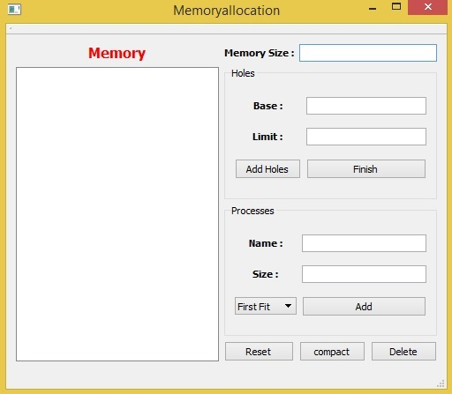

**First Choose Memory Size**

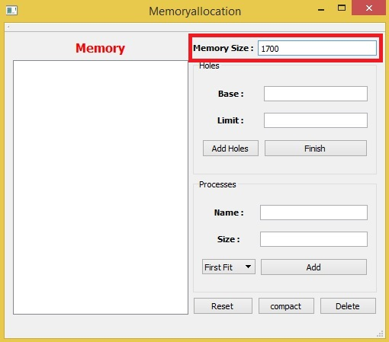

**Then Add Holes  
write Base & Limit Then click Add Holes**

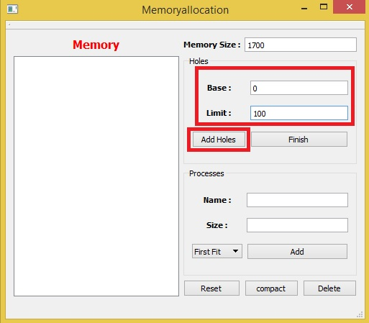

**You can Add Holes with Different and separate Bases**

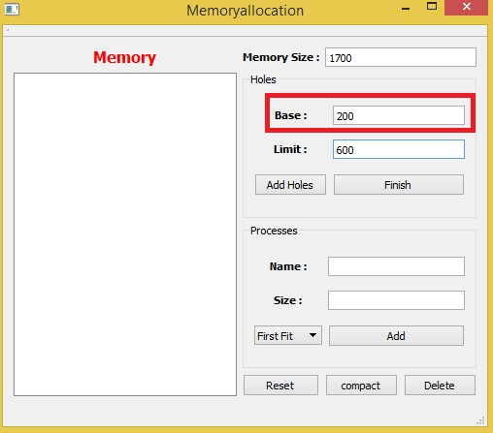

**After Adding all Holes Click Finish**

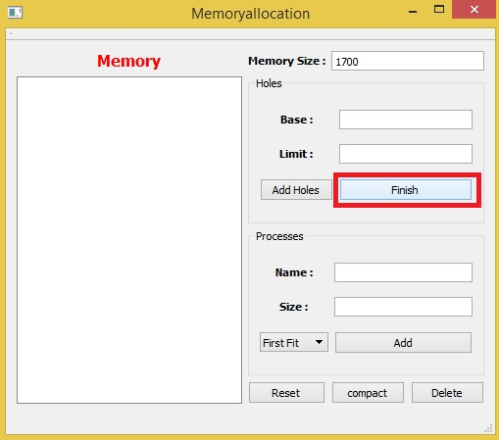

**After Clicking Finish the Memory will be drawn**

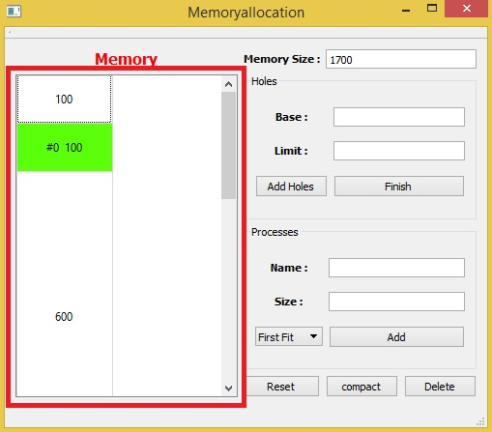

**Holes : will take white color and its size will appear**

**Predefined Processes : Will Appear if there are spaces between Holes And it Will Take name #n**

**Where n is unique number**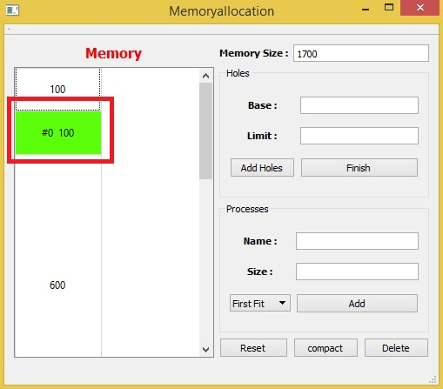

**Predefined Processes : will Appear in every space without Holes even it in end or start**

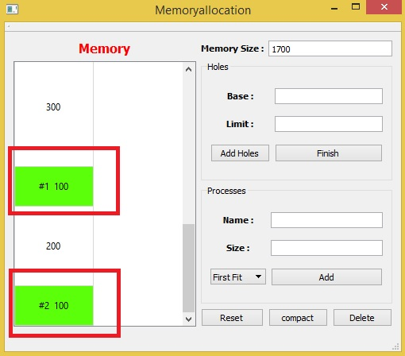

**Now Add Processes**

**Write Name & Size Then choose the Algorithm  
First Fit**

**Best Fit**

**Worst Fit**

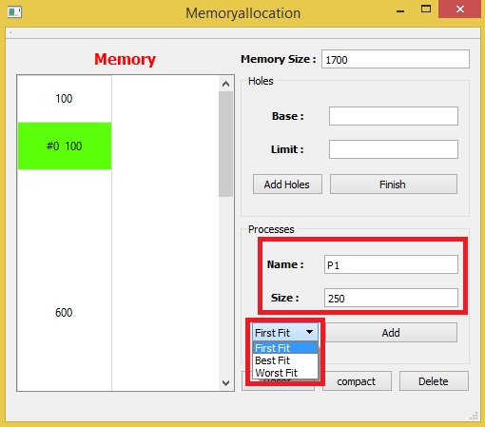

**After setting Process Values Click Add**

**When you click it will be drawn immediately**

**Process Name & Size Will appear** 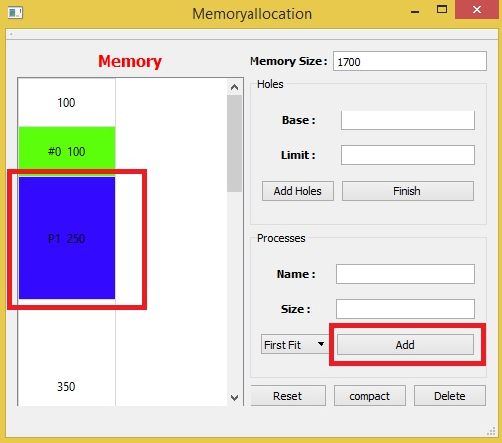

**Best Fit Process**

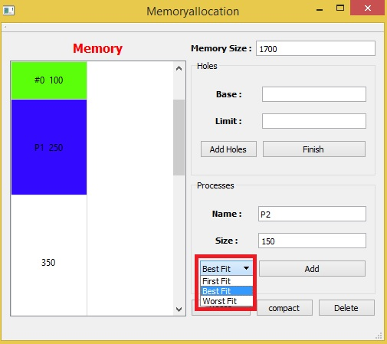

**Will Fit in Smallest Hole Can fit it**

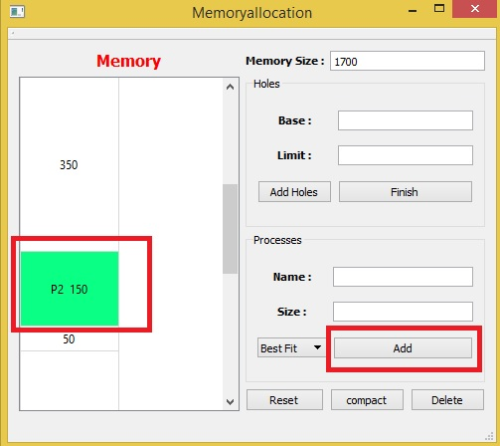

**Worst Fit Process**

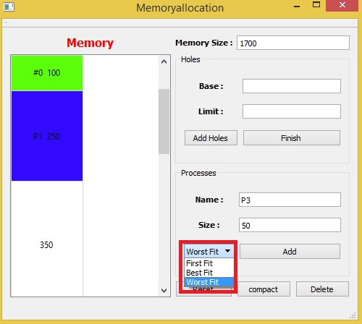

**Will Fit in Largest Hole Can fit it**

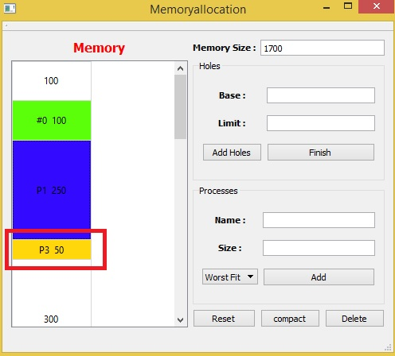

**Mouse Over Any Process or Hole To see Its Start & End**

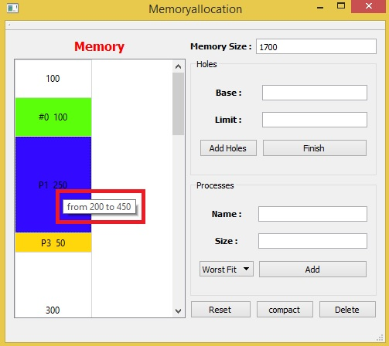

**Delete Process**

**Click on Any Process In Memory Draw Then Click Delete**

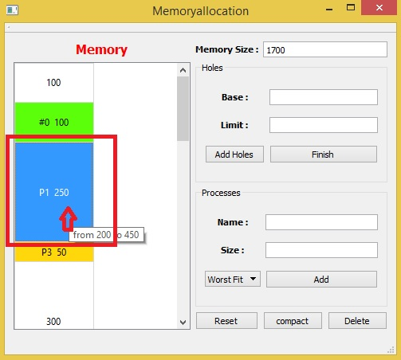

**After Clicking Delete Its Space Will be Free Hole**

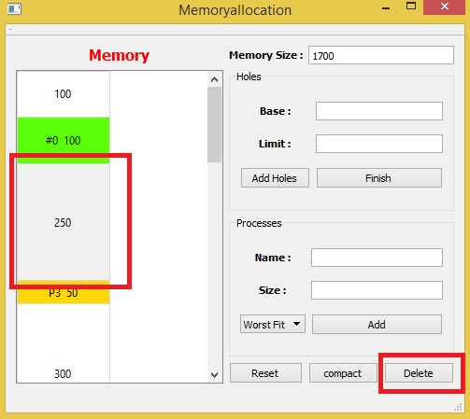

**Adding Large Process**

**If you add New Process with Large Size That will not Fit Any Hole**

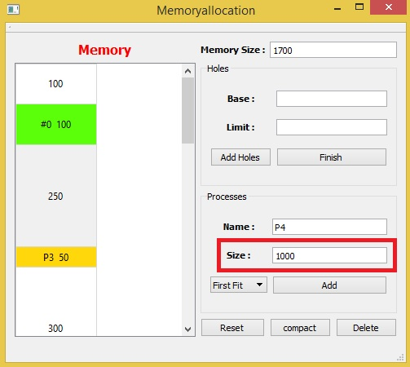

**An Error Message Will Appear Warning You That Process Will not fit**

**and advice you to deallocate a process or Click Compact**

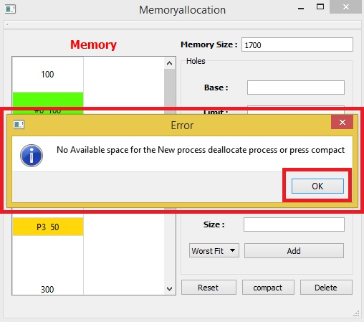

**Compact**

**You can click it any time to compact Memory**

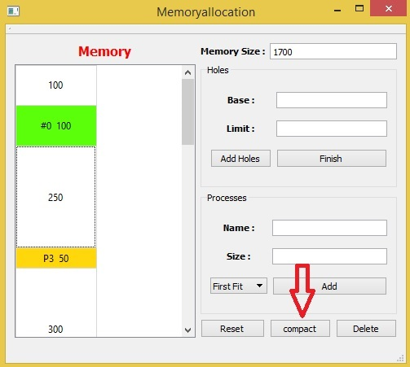

**After Click All Processes will be compressed  
and all holes will be combined together and create a big sized hole Can be fit for big process**

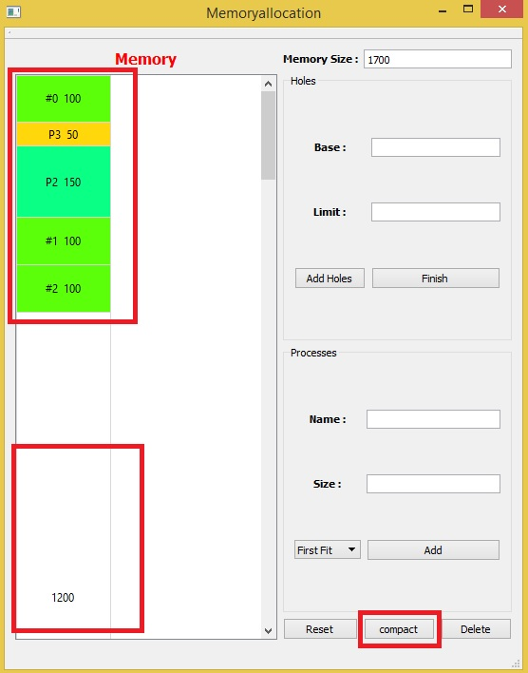

**Reset  
Click reset Any time To Reset Program**

